E-Waste Recycling App - Deliverables for API Interface

Project Overview
The goal is to create a mobile application (Android and iOS) that encourages and facilitates responsible disposal of electronic waste by enabling users to recycle their gadgets in exchange for monetary value or credit points. The system utilizes AI-based image verification to assess device condition and assign recycling value accordingly.

Schema Architecture - ERD (Entity Relationship Diagram)
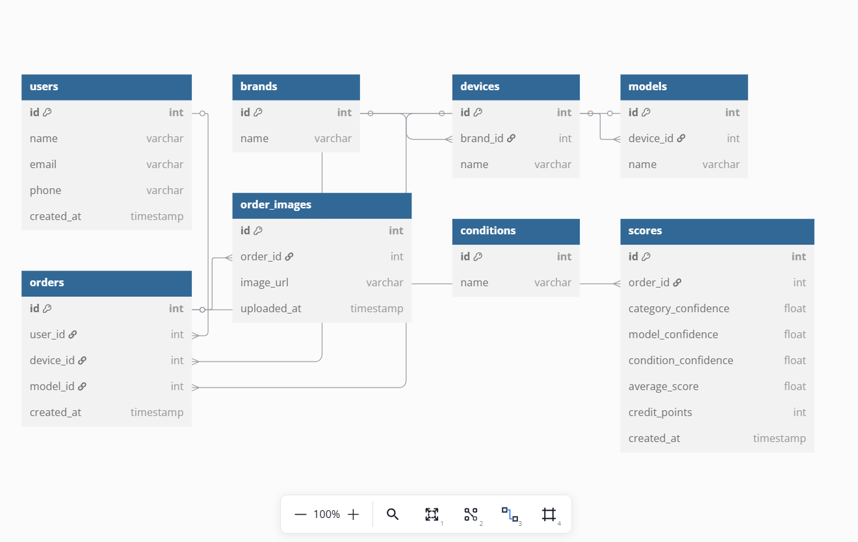

Master Data (Sample Entries)
Categories:
- Mobile Phone
- Laptop
- TV
- Refrigerator
- Washing Machine
- Air Conditioner
Devices (Examples):
- iPhone, Samsung Galaxy (for Mobile Phone)
- HP Pavilion, Dell Inspiron (for Laptop)
- LG Smart TV, Sony Bravia (for TV)
Models (Examples):
- iPhone 13, iPhone XR
- HP Pavilion 15
- Sony Bravia 55X80L
Conditions:
- Working
- Minor Defects
- Not Working
- Physically Damaged

